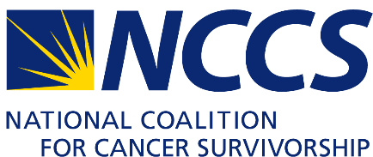
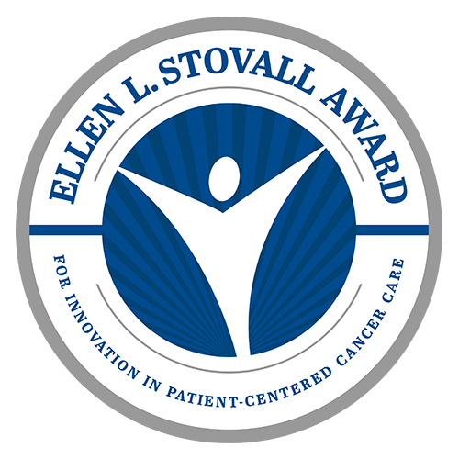

AWARD RECEPTION - OCTOBER 19, 2017

SPONSORSHIP LEVELS & BENEFITS

PRESENTING SPONSOR (EXCLUSIVE) - $100,000
- Thirty tickets to Stovall Award Reception
- Complimentary valet parking for up to 10 vehicles
- On stage recognition of organization as Presenting Sponsor
- Logo recognition as Presenting Sponsor on invitation, event signage and sponsor video presentation
- Full page color ad in the program book
- Sponsorship acknowledgement on the Stovall Award website and NCCS website
- Sponsorship acknowledgement in event media advisory

PREMIER SPONSOR - $50,000
- Twenty tickets to Stovall Award Reception
- Complimentary valet parking for up to 5 vehicles
- On stage recognition of organization as Premier Sponsor
- Logo recognition as Premier Sponsor on event signage and the sponsor video presentation
- Half page color ad in the program book
- Sponsorship acknowledgement on the Stovall Award website and NCCS website

PLATINUM SPONSOR - $25,000
- Twelve tickets to Stovall Award Reception
- On stage recognition of organization as Platinum Sponsor
- Logo recognition as Platinum Sponsor on event signage and the sponsor video presentation
- Half page color ad in the program book
- Sponsorship acknowledgement on the Stovall Award website and NCCS website

GOLD SPONSOR - $10,000
- Ten tickets to Stovall Award Reception
- Acknowledgement in the sponsor video presentation and program book
- Sponsorship acknowledgement on the Stovall Award website and NCCS website

SILVER SPONSOR - $5,000
- Six tickets to Stovall Award Reception
- Acknowledgement in the sponsor video presentation and program book
- Sponsorship acknowledgement on the Stovall Award website and NCCS website

BRONZE SPONSOR - $2,500
- Four tickets to Stovall Award Reception
- Acknowledgement in the sponsor video presentation and program book
- Sponsorship acknowledgement on the Stovall Award website and NCCS website

SUPPORTER - $1,000
- Two tickets to Stovall Award Reception
- Acknowledgement in the sponsor video presentation and program book

INDIVIDUAL TICKET - $200
- One ticket to Stovall Award Reception

Recognition of benefits is subject to print deadlines.
Award reception will be held October 19, 2017 at the Four Seasons Hotel in Washington, DC

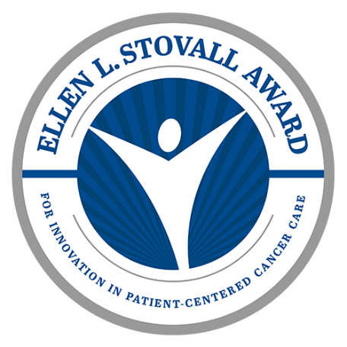
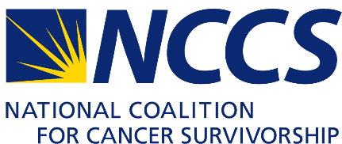

SPONSORSHIP RESPONSE FORM

Name or Organization (as it should appear on all marketing materials)

Contact Name Title

Address

City State Zip

Telephone Email

I/We would be pleased to support the Ellen L. Stovall Award at the following level:

Presenting Sponsor ~ $100,000 Premier Sponsor ~ $50,000

Platinum Sponsor ~ $25,000 Gold Sponsor ~ $10,000

Silver Sponsor ~ $5,000 Benefactor ~ $2,500

Supporter ~ $1,000 Individual Ticket ~ $200

I/We would like to be recognized as follows:

I/We would like to be listed anonymously.

Payment Method:
Enclosed is a check for $ (please make check payable to the National Coalition for Cancer Survivorship).
Please charge my/our credit card for $ .
MasterCard Visa AmEx Discover
Cardholder’s Name (as it appears on card): __________
Card Number: Exp Date: Security Code:
Signature (required for all pledges):
Please send your completed response by email to ejeannotte@canceradvocacy.org, or send by mail to:
National Coalition for Cancer Survivorship

8455 Colesville Road, Suite 930

Silver Spring, MD 20910
Thank You for Your Support!

The National Coalition for Cancer Survivorship is a 501(c)(3) organization. Contributions are tax-deductible to the extent allowed by law. All contributors will receive an official tax receipt from the National Coalition for Cancer Survivorship.
Tax Identification Number: 85-0357897

