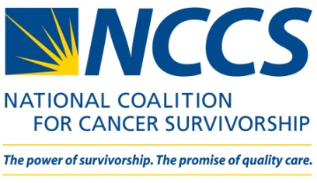

Report on a Visit to a District Congressional Office

Name of advocate completing this form: _________________________________________________________
Other advocates in the meeting, if any: __________________________________________________________
__________________________________________________________________________________________

Congressional office: ________________________________________________________________________
Meeting location: ___________________________________________________________________________

With whom did you meet (i.e., member of Congress or staffer)? ______________________________________
__________________________________________________________________________________________

Please note the name and title of the staffer.

Date of meeting: ____________________________________________________________________________

Was the legislator or staff aware of NCCS? Yes: _____ No: _____

Does anyone in the office have a personal connection to cancer? Yes: _____ No: _____

if yes, please describe: ____________________________________________________________________

How interested is the office in the PACT Act? _____________________________________________________

What is the position of the member of Congress on the PACT Act?
Supports the PACT Act _____
Considering supporting the PACT Act _____
Would not say/undecided _____
Considering opposing the PACT Act _____
Opposes the PACT Act _____
I’m not sure_____

For the House: Is the office willing to co-sponsor the PACT Act? Yes: _____ No: _____ Possibly: _____

For the Senate: Is the office interested in introducing the companion bill in the Senate? Yes: _____ No: _____
Possibly: _____

Did the legislator and/or staffer have any concerns about the PACT Act? Yes: _____ No: _____

if yes, please describe: ____________________________________________________________________

Did the legislator and/or staffer have any requests such as follow-up by NCCS staff or additional background on the PACT Act or ask to hear from more constituents who support the PACT Act? Yes: _____ No: _____

if yes, please describe: ____________________________________________________________________

Did the office raise any other issues that are relevant to the PACT Act? Yes: _____ No: _____

if yes, please describe: ____________________________________________________________________

Is there anything else NCCS staff should know about this meeting? ____________________________________

__________________________________________________________________________________________

__________________________________________________________________________________________

__________________________________________________________________________________________

Please return this form to NCCS as soon as possible after your meeting by emailing it to Christin Engelhardt at cengelhardt@canceradvocacy.org.

Thank you for your efforts!!

